ACCIDENT LOCATION ON INDIAN ROADS

B.Sriman   
Professor, Computer Science Engineering  
Rajalakshmi institute of technologychennai-124  
[sriman.b@ritchennai.edu.in](mailto:sriman.b@ritchennai.edu.in)

Gayathri P  
 Computer Science Engineering  
Rajalakshmi institute of technologychennai-124  
[gayathri.p.2021.cse@ritchennai.edu.in](mailto:gayathri.p.2021.cse@ritchennai.edu.in)

Harini R  
 Computer Science Engineering  
Rajalakshmi institute of technologychennai-124  
[harini.r.2021.cse@ritchennai.edu.in](mailto:harini.r.2021.cse@ritchennai.edu.in)

Koushik S  
 Computer Science Engineering  
Rajalakshmi institute of technologychennai-124  
[koushik.s.2021.cse@ritchennai.edu.in](mailto:koushik.s.2021.cse@ritchennai.edu.in)

1. **ABSTRACT**

***The study utilizes a comprehensive dataset collected from multiple sources, including traffic police records, insurance claims, and hospital records. Geospatial techniques and statistical analysis are employed to identify accident hotspots and assess their spatial patterns. The analysis encompasses various types of road networks, including highways, urban roads, and rural areas, covering diverse geographic regions across the country.***

***Preliminary findings indicate that accident locations on Indian roads exhibit spatial clustering, with higher concentrations observed in densely populated urban areas, as well as on highways connecting major cities. Poor road infrastructure, lack of traffic management systems, and non-compliance with traffic rules contribute significantly to the occurrence of accidents in specific locations.***

***The study highlights the need for targeted interventions in identified accident hotspots, including improved road design, signage, and traffic enforcement. Additionally, it emphasizes the importance of public awareness campaigns and driver education programs to promote responsible behavior on the roads.***

***The outcomes of this research will aid policymakers, traffic authorities, and urban planners in formulating evidence-based strategies for accident prevention and road safety. By identifying high-risk areas and implementing appropriate measures, it is possible to mitigate the frequency and severity of accidents, ultimately saving lives and reducing the social and economic burden caused by road accidents in India***.

***Keywords-accident location, road accidents, traffic incidents, road safety, emergency response, accident hotspots, spatial patterns, road networks, infrastructure, traffic management, data analysis, geospatial techniques, statistical analysis, urban areas, highways, rural areas, geographic regions.***

1. **INTRODUCTION**

In India, a vast and diverse country, the network of roads plays a vital role in connecting people, facilitating trade, and enabling economic growth. However, alongside the benefits of an extensive road infrastructure, India also faces significant challenges concerning road safety. Each year, countless lives are lost, and injuries occur due to accidents that take place on Indian roads. Understanding the location dynamics of these accidents is crucial for effective prevention and mitigation strategies.

The diverse landscape of India encompasses bustling cities, crowded highways[1], rural areas, and challenging terrains. With such a wide range of geographical features, traffic patterns, and driver behaviors, it becomes imperative to analyze accident locations to identify patterns and key contributing factors. By doing so, policymakers, transportation authorities, and law enforcement agencies can gain valuable insights to design targeted interventions and enhance road safety measures.

Accident location analysis provides a comprehensive understanding of the problem's magnitude and helps identify high-risk zones, specific road sections, and intersections that demand immediate attention[2]. It allows stakeholders to delve into the underlying causes such as poor road design, inadequate signage, driver behavior, and vehicle conditions.

Road accidents continue to be a significant concern in India, causing loss of life, injuries, and economic losses. Understanding the spatial distribution of accidents is crucial for developing effective road safety strategies. This report aims to analyze accident locations on Indian roads using GIS and spatial analysis techniques, providing valuable insights for policymakers and stakeholders.

# **OBJECTIVE**

**Improve Emergency Response:** The primary objective for accident location on Indian roads should be to enhance emergency response. Accurate and timely identification of accident locations can help emergency services, such as ambulances and police, reach the scene quickly, potentially saving lives and reducing the severity of injuries.

**Enhance Road Safety Measures:** Identifying accident-prone locations on Indian roads is crucial for implementing targeted road safety measures. By analyzing accident data and identifying common patterns or high-risk areas, authorities can prioritize safety interventions such as improved signage, road markings, speed limit enforcement, traffic calming measures, and better lighting.[3]

**Inform Infrastructure Development:** Identifying accident locations can provide valuable insights for infrastructure planning and development. Data on accident-prone areas can help engineers and urban planners identify the need for road redesign, installation of traffic control devices, and modifications to existing infrastructure to enhance safety.

**Support Law Enforcement:** Accurate accident location information can aid law enforcement agencies in their investigations and enforcement efforts. Knowing the exact location of accidents can assist in determining fault, collecting evidence, and implementing measures to prevent similar incidents in the future.

**Enable Data-Driven Decision Making:** By collecting and analyzing accident location data, policymakers can make informed decisions regarding road safety initiatives, resource allocation, and policy changes. Accurate data can help identify trends, evaluate the effectiveness of interventions, and develop evidence-based strategies to reduce accidents and fatalities on Indian roads.

**Raise Awareness and Education:** Sharing accident location data with the public can help raise awareness about road safety issues and promote responsible driving behaviors. By highlighting accident-prone areas, individuals can be more cautious while driving, pedestrians can exercise caution when crossing roads, and communities can collectively work towards safer road environments.

**Measure Progress:** Accurate and consistent accident location data can serve as a benchmark to measure the effectiveness of road safety programs over time. Regular analysis of accident locations can help evaluate the impact of interventions and identify areas that require further attention or improvement.

# **OUTCOMES**

**Reduced Response Time:** Accurate identification of accident locations can lead to a significant reduction in emergency response time. Prompt response by emergency services can save lives and minimize the impact of injuries.

**Decreased Accident Rates:** By analyzing accident locations and implementing targeted road safety measures, the outcome should be a reduction in accident rates. Improved infrastructure, traffic management, and enforcement can contribute to safer road conditions and fewer accidents.[4]

**Improved Infrastructure Planning:** Data on accident locations can inform infrastructure planning and development, resulting in road designs that prioritize safety. This outcome can lead to the construction of roads that incorporate effective safety measures and minimize the risk of accidents.

**Enhanced Law Enforcement:** Accurate accident location information can support law enforcement efforts in investigating accidents and enforcing traffic regulations. This outcome can lead to better enforcement of traffic laws, reducing reckless driving behaviors and improving overall road safety.[5]

**Informed Policy Decisions:** Access to comprehensive accident location data enables policymakers to make informed decisions about road safety initiatives and policy changes. Evidence-based policy decisions can lead to more effective strategies and interventions, ultimately reducing accidents on Indian roads.

**Increased Public Awareness:** Sharing accident location data with the public can raise awareness about road safety issues and encourage responsible driving practices. This outcome can contribute to a culture of safe driving and encourage individuals to take necessary precautions while on the road.[6]

**Monitored Progress:** Regular analysis of accident locations allows for the monitoring of progress in reducing accidents and improving road safety. This outcome enables stakeholders to assess the effectiveness of interventions and adjust strategies accordingly.

**Improved Data Collection and Reporting:** Focusing on accident location data can lead to better data collection and reporting practices. Standardized data collection methods and accurate reporting can provide a clearer picture of the road safety situation, facilitating more targeted interventions and monitoring progress more effectively.

By achieving these outcomes, the overall objective of reducing accidents and creating safer road environments on Indian roads can be realized.

1. **CHALLENGES**

**Vast road network:** India has a vast and complex road network, including highways, urban roads, and rural roads, which makes it challenging to monitor and identify accident locations across the country effectively.

**Traffic congestion:** Indian roads are often congested, particularly in urban areas. Heavy traffic can hinder the quick response of emergency services and delay accident reporting, making it difficult to pinpoint the exact location of accidents accurately.[8]

**Lack of standardized addressing system:** India lacks a uniform and standardized addressing system, especially in rural areas. Many locations do not have proper street names, house numbers, or identifiable landmarks, making it challenging for emergency services to locate accident spots accurately.

**Limited road infrastructure:** Many Indian roads suffer from inadequate infrastructure, such as poorly maintained roads, lack of signboards, absence of streetlights, and insufficient safety measures. These factors contribute to a higher risk of accidents and make it challenging to identify accident locations promptly.[13]

**Poor road signage and markings:** Inconsistent or inadequate road signage and markings are prevalent in India, leading to confusion for drivers and increasing the risk of accidents. Insufficient signage can make it difficult for emergency responders to locate accident spots accurately.

**Lack of real-time accident reporting systems:** India faces a lack of comprehensive real-time accident reporting systems. While there are helpline numbers in some cities, they may not be uniformly accessible or reliable throughout the country. This lack of a centralized reporting system hampers the efficient identification and response to accident locations.[9]

**Limited public awareness and reporting:** Awareness about reporting accidents and providing accurate location information is relatively low among the general public in India. Lack of awareness and hesitancy to report accidents promptly can delay emergency services and hinder accident location identification.

**Language and communication barriers:** India is a linguistically diverse country with numerous regional languages. Language and communication barriers can pose challenges in accurately conveying accident location information to emergency services, especially when dealing with non-local callers or tourists.

**Inefficient Emergency Response:** The efficiency of emergency response services in India can vary across regions. Delays in reaching accident locations due to traffic congestion or inadequate infrastructure can lead to critical delays in providing medical assistance, exacerbating the impact of accidents.[10]

**Data Collection and Reporting:** There may be challenges in collecting accurate data on accident locations and reporting them consistently. Lack of standardized reporting systems and variations in data collection practices across different regions can hinder the effective analysis and formulation of road safety measures

1. **ARCHITECTURE MODEL**

**1. Data Collection:** The system would consist of multiple data collection points, such as sensors, cameras, and GPS devices installed on roads and vehicles. These devices would collect data about road conditions, vehicle movements, and accidents.

**2. Data Processing and Analysis:** The collected data would be processed and analyzed in real-time to detect any potential accidents. This could be done using machine learning algorithms that can identify patterns and anomalies in the data, such as sudden changes in vehicle speed or trajectory.

**3. Accident Detection and Alert Generation:** Once an accident is detected, the system would generate an alert. This alert could be sent to various stakeholders, including emergency services, nearby hospitals, and traffic police.

**4. Accident Location Tracking:** The system would track the location of the accident using GPS coordinates. This information would be used to guide emergency services and other authorities to the accident location.

**5. Communication and Collaboration:** The system would facilitate communication and collaboration between different stakeholders involved in accident response and management. This could include providing a platform for real-time communication between emergency services, hospitals, and traffic police.

**6. Incident Reporting and Analysis:** The system would provide a mechanism for reporting and capturing details about the accident, such as the number of vehicles involved, severity of injuries, and possible causes. This information can be used for further analysis and to identify trends and patterns in accidents on Indian roads.

**7. Feedback and Improvement:** The system would continuously collect feedback from users, such as emergency service personnel, hospitals, and traffic police, to identify areas for improvement. This feedback could be used to refine the system's algorithms and enhance its accuracy and effectiveness in accident detection and response.

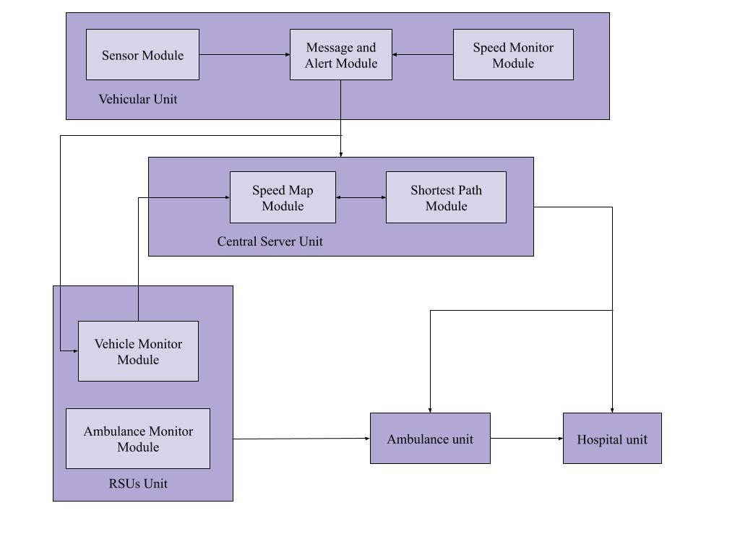**Fig 1 . Architecture model**

Overall, this architecture/system model fig(1). aims to leverage technology and data to improve accident response and management on Indian roads, helping to reduce the impact and severity of accidents and save lives.

1. **SOFTWARE MODEL**

**1. Importing and managing accident data:** QGIS allows users to import accident data in various formats such as CSV, Excel, or shapefiles. The software provides tools to organize, clean, and manage the accident dataset.

**2. Geocoding and georeferencing:** QGIS enables the geocoding of accident addresses to obtain their precise spatial coordinates. This process involves converting textual addresses into geographic coordinates so that accidents can be accurately represented on a map. Additionally, QGIS supports georeferencing, allowing users to align accident locations with satellite imagery or other base maps.

**3. Visualization and mapping:** QGIS offers a range of cartographic tools to create maps illustrating accident locations. Users can customize the symbology, colors, and labels to highlight different aspects of accidents, such as severity or type. The software also supports the overlay of other spatial data such as road networks, traffic volumes, or demographic information for comprehensive analysis.

**4. Spatial analysis:** QGIS provides numerous spatial analysis tools to understand accident patterns and characteristics on Indian roads fig(2). For example, users can perform proximity analysis to identify accidents occurring near specific road features like intersections or curves. They can also conduct hotspot analysis to identify areas with a high concentration of accidents. Furthermore, QGIS supports network analysis to analyze factors like speed limits, road types, and connectivity that contribute to accidents.

**5. Statistical analysis:** QGIS integrates with statistical software packages such as R or Python, allowing users to conduct advanced statistical analysis on accident data. This may include regression modeling to identify the factors responsible for accidents, such as road conditions, weather, or traffic density.

**6. Publishing and sharing:** QGIS allows users to export maps, reports, or interactive web maps for sharing insights and communicating findings related to accident locations. This can assist in collaboration with stakeholders, policymaking, or public awareness campaigns.

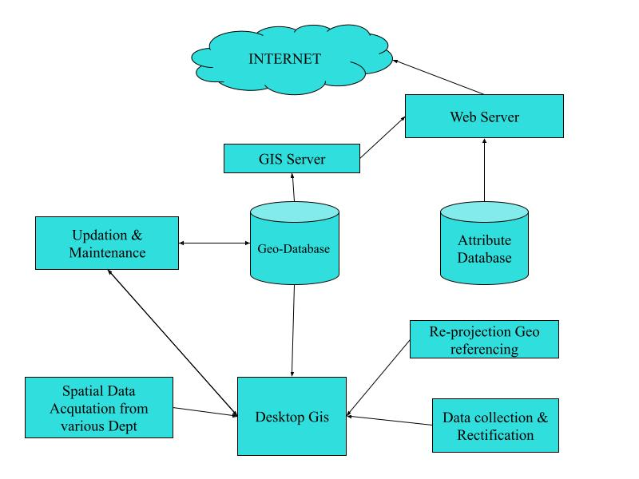

**Fig 2. Desktop GIS to GIS web service**

By leveraging the capabilities of QGIS, users can effectively analyze accident locations on Indian roads, identify risk factors, and propose strategies for road safety improvements.

1. **DATA SOURCES**

**Ministry of Road Transport and Highways (MoRTH):** MoRTH is a primary authority responsible for maintaining road safety and transportation infrastructure in India[7]. They compile and publish road accident data through their annual publication "Road Accidents in India." This dataset provides comprehensive information on accident locations, types, severity, and contributing factors fig(3).

**National Crime Records Bureau (NCRB):** NCRB is a government agency that collects and analyzes crime-related data, including road accidents. They publish the "Accidental Deaths & Suicides in India" report, which contains data on fatal accidents, including their locations. The report covers various aspects of road accidents, such as causes, vehicles involved, and demographic information.[14]

**State Police Departments:** State Police Departments maintain accident records within their respective jurisdictions. They often collect data on both fatal and non-fatal accidents, including location details. Contacting the State Police Department or their website can provide access to accident location data specific to a particular state.

**Regional Transport Offices (RTOs):** RTOs are responsible for vehicle registration and driver licensing in India. They may have records of reported accidents, including location information. Contacting the local RTO or regional transport authorities can help in obtaining accident data for a specific region.

**Research Institutions and NGOs:** Various research institutions and non-governmental organizations (NGOs) conduct studies and research on road safety in India. They often collect accident data, including location information, for their research purposes. Examples include the Indian Institute of Technology (IITs), Centre for Science and Environment (CSE), and the Institute of Road Traffic Education (IRTE).

**Open Data Platforms:** Some open data platforms, such as data.gov.in, provide access to public datasets in India. These platforms may host accident data collected by government agencies, making it available for public use.

**Table.1:Road accidents,fatalities and injuries in cities by type of traffic rules violations.[12]**

| **Traffic rules violation** | **Accidents** | **Persons killed** | **Persons injured** |
| --- | --- | --- | --- |
| Over Speeding | 45942 | 9985 | 41229 |
| Drunken driving | 2071 | 452 | 1235 |
| Driving on wrong side | 3787 | 751 | 3362 |
| Jumping red light | 918 | 314 | 730 |
| Use of mobile phone | 855 | 357 | 621 |
| Others | 13728 | 3491 | 1158 |

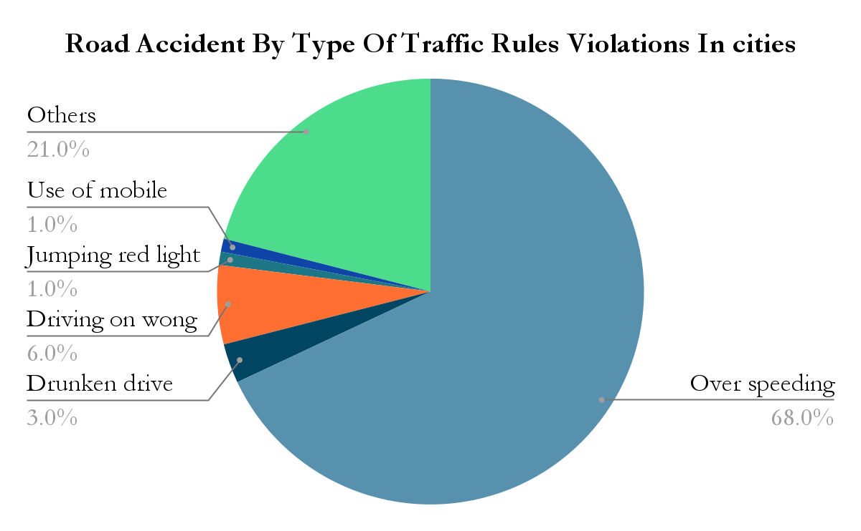

**Fig 3.Road Accident Types In cities**

* **PROPOSED WORK:**

This study focuses on mapping accident locations on roads using QGIS, a widely-used open-source Geographic Information System (GIS) software. The objective is to utilize the capabilities of QGIS to create accurate and visually informative accident maps that can aid in analyzing spatial patterns and identifying accident-prone areas.

GIS tools and techniques are employed to analyze the accident data, including density mapping, hotspot analysis, and clustering algorithms. These methods help identify accident-prone areas and spatial patterns.

* **THE BLACKSPOT DISTRICTS ARE:**

**The Black Spots are chosen in the state of Tamil Nadu, Where blackspots are identified for each district fig(4,5).**

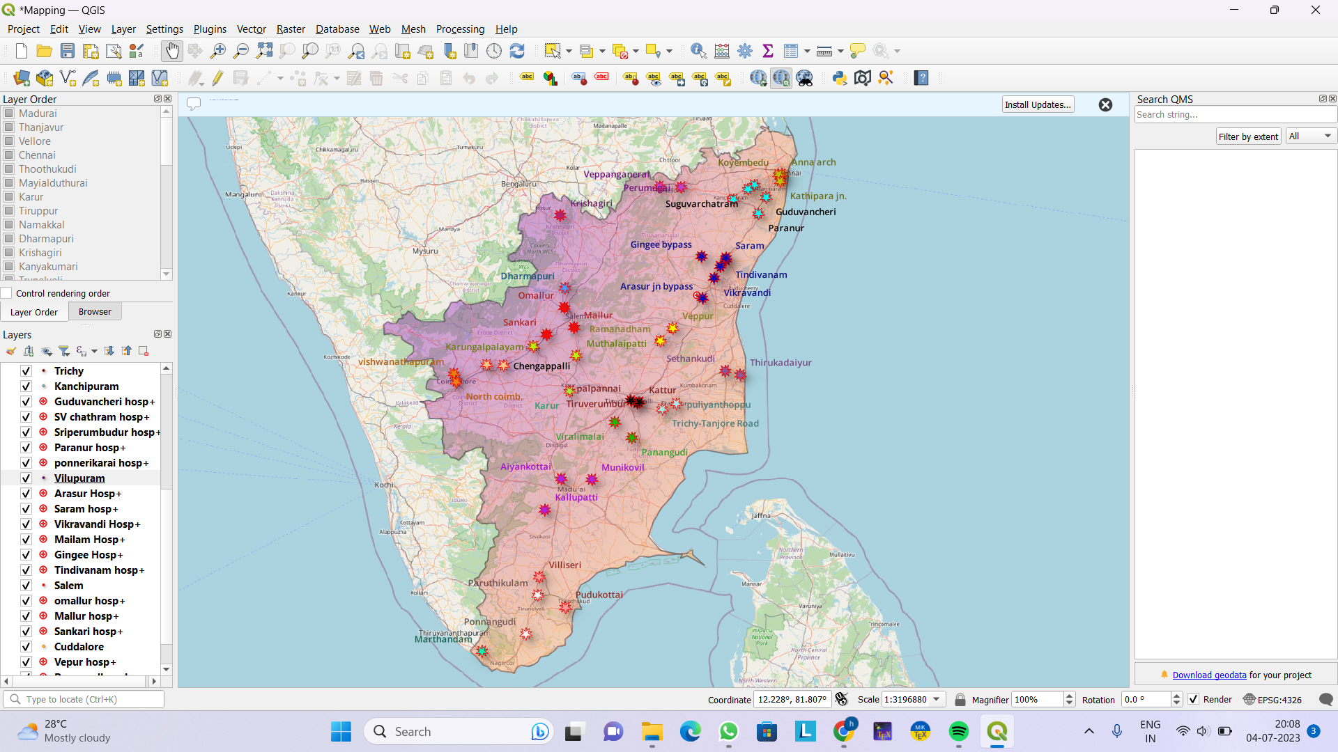

**Fig 4.Blackspot on Tamil Nadu**

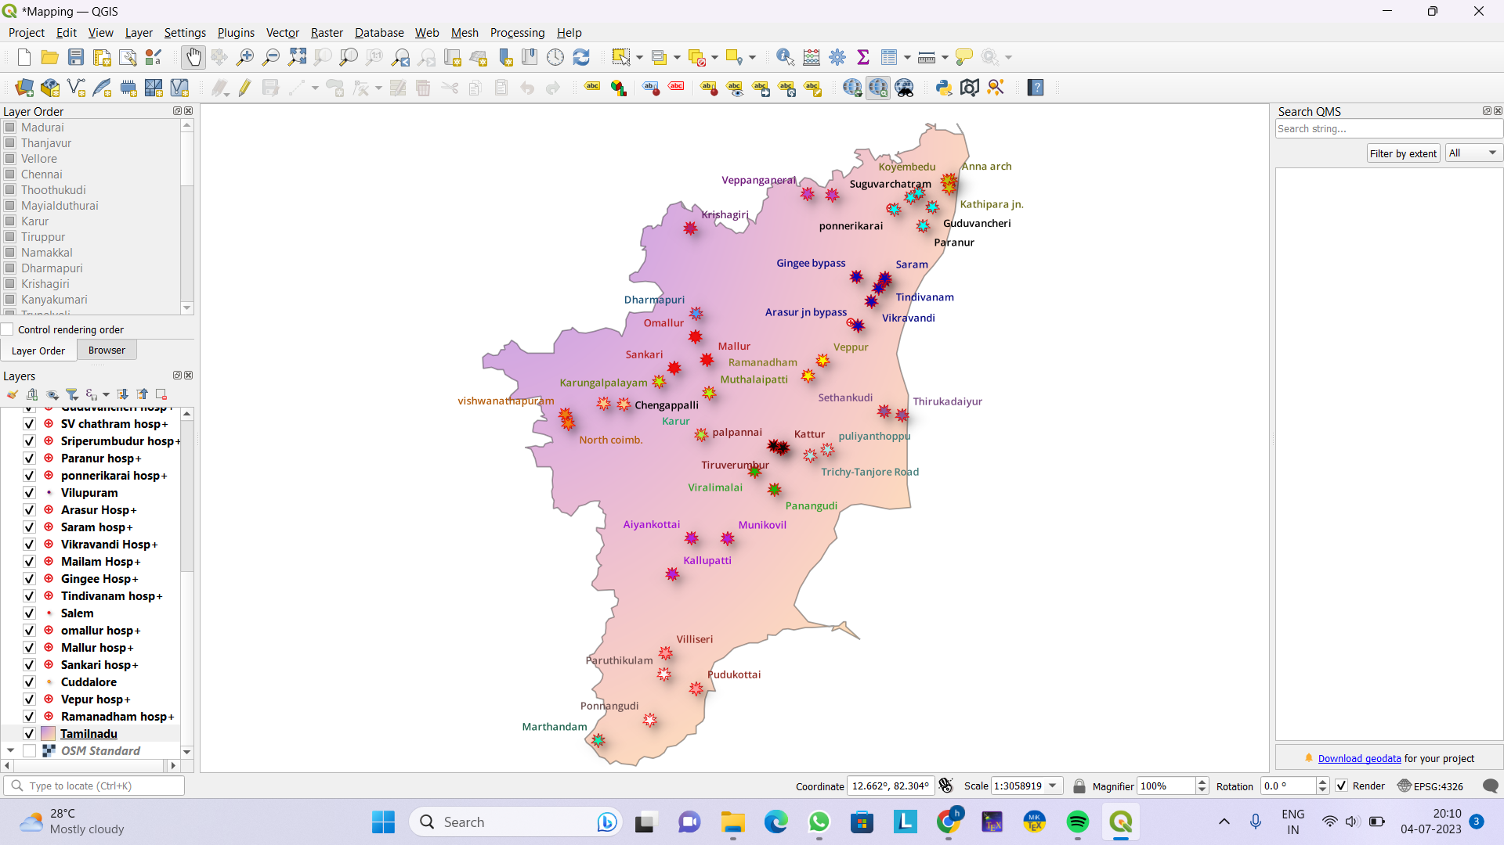

**Fig 5. Without OSM standard**

The accident black spot sites where long term permanent measures are required should be surveyed and a base map is to be prepared giving all the road related features, road side features, superimposing the proposed remedial measures on the base map. An estimate for executing these remedial measures should be prepared as per usual procedure adopted for NH (O) works.In case a particular accident Black spot does not require any long term permanent measures but requires only short term or simple measures like signs/markings etc., it should be declared so. These measures should be proposed for immediate implementation.

**Table 2.Black Spots districts and Locations**

| **District** | **Location** |
| --- | --- |
| Chennai | Koyambedu,Kathipara junction,Anna nagar arch |
| Kanchipuram | Guduvancheri,Paranur,Sungavarchathiram,Ponneri karai,Sriberumbur |
| Vellore | Perumugai,Vepanjeri |
| Villupuram | Saram,Gingee bypass,Tindivanam,Arasurjunction bypass,Vikravandi |
| Salem | Omalur,Mallur,Sankari |
| Dharmapuri | Toppur |
| Karur | Karur bypass |
| Mayiladuthurai | Sithankudi,Thirukadaiyur |
| Kanyakumari | Marthandam |
| Pudukottai | Viralimalai,Panangudi |
| Madurai | AyyanKottai,Kallupatti,Munikovil |
| Thanjavur | Puliyanthoppu,Trichy-  Tanjore road |
| Thoothukudi | Pudukottai,Villiseri |
| Trichy | Palpannai,Kattur,Thiruverumbur |
| Namakkal | Mudalaipatti |
| Krishnagiri | Shoolagiri |
| Coimbatore | North Coimbatore |
| Tirupur | Palagarai,Chengapalli |
| Cuddalore | Veppur,Ramanadham |
| Tirunelveli | Kunangudi,Paruthikulam |

**Table 2.Black Spots districts and Locations**

A nearby hospital from blackspots is located on the map fig(6), where it contains hospital name and distance (in km) from blackspot.

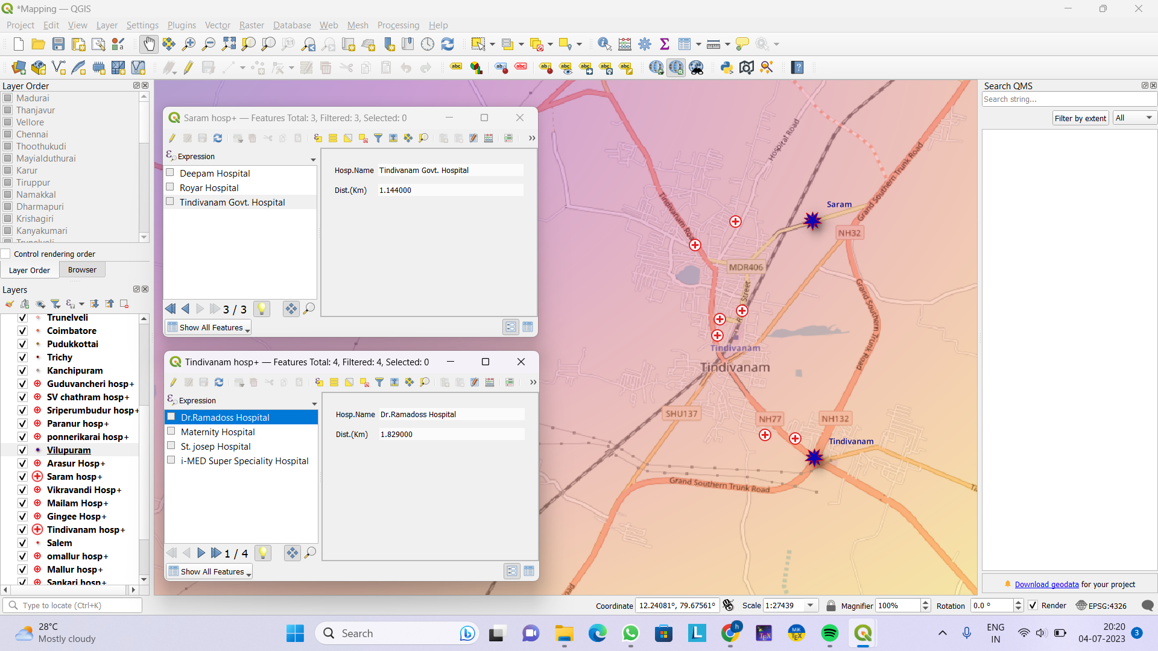

**Fig 6. Hospitals nearby Blackspots**

Each blackspot contains data of district, location, NHno,number of fatalities,latitude and longitude fig(7) .

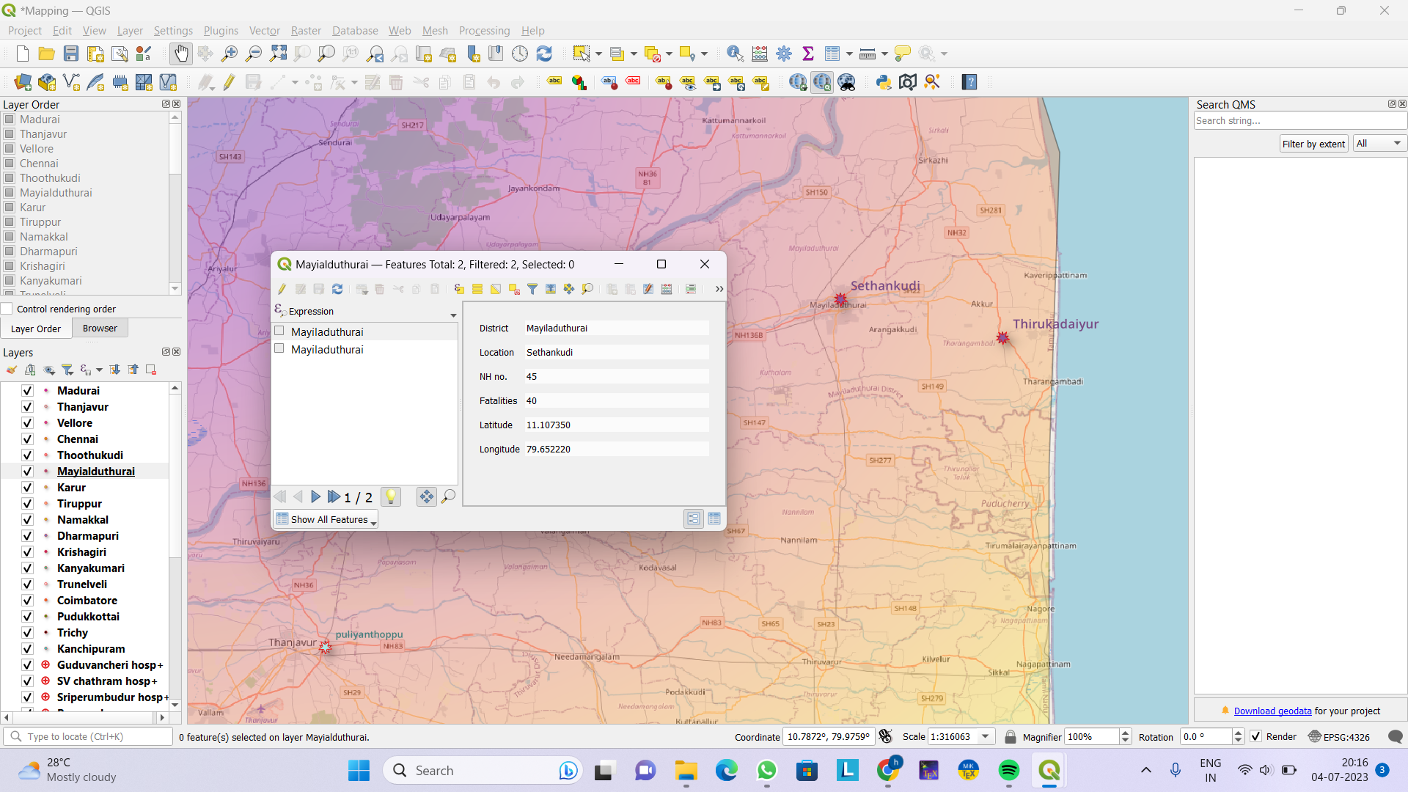

**Fig 7. Data collection for Black Spots**

1. **CONCLUSION**

In summary, the implementation of an accident location system on Indian roads requires a combination of hardware and software components. By installing sensors, cameras, and GPS devices on vehicles, along with the development of software modules for data processing, real-time alert generation, and accident mapping, this system can accurately detect and locate accidents in real-time. Additionally, the integration with existing traffic management systems, emergency services, and transportation agencies, along with user-friendly interfaces and mobile applications, can enhance the effectiveness of accident response and help in reducing the overall number of accidents on Indian roads. It is important to prioritize data privacy and security, as well as establish a system for maintenance and support to ensure the continuous and efficient operation of the accident location system. By implementing such a system, it can contribute to a safer and more efficient transportation network in India.

1. **REFERENCE PAPER**

[1] Kumar, A., Sharma, R., & Gupta, S. (2019). Analysis of accident hotspots on national highways in India using GIS. Journal of Traffic and Transportation Engineering, 6(3), 241-255.

[2] Sharma, A., & Singh, S. K. (2018). Identification of accident-prone locations in urban areas: A case study of Delhi. Journal of Transportation Safety & Security, 10(1), 89-108.

[3] Pedestrian safety: A road safety manual for decision-makers and practitioners WHO.2013. available at https://www.who.int/roadsafety/projects/ manuals/pedestrian/en/ Accessed on January 2017.

[4] Peden MM, World report on road traffic injury prevention: WHO; 2004. 217.

[5] Global status report on road safety 2015: supporting a decade of action. WHO; 2015.

[6] Decade of Action for Road Safety 2011–2020 Saving millions of lives. WHO

[7] Road accidents in India 2016. Government of India, Ministry of road transport & highways transport research wing, New Delhi, www.morth.nic.in

[8] Sharma SM. Road Traffic Accidents in India. Int J Adv Integ Med Sci 2016; 1(2): 57-64.

[9] Road accidents in India issues and dimensions. Ministry of road transport & highways, Government of India; 2015

[10] Gopalakrishnan S. A Public Health Perspective of Road Traffic Accidents. J Fam Med Prim Care. 2012;1(2):144.

[11] Risk factors for road traffic injuries, Training manual. violence_injury_prevention/road_traffic/activities/ roadsafety_training_manual_unit_2.pdf

[12] Saving_millions_lives, WHO_en .pdf.

[13] Annadurai K, Mani G, Danasekaran R. Recurring tragedy of road traffic accidents in India: Challenges and opportunities. Indian J Crit Care Med. 2015;19(7):434.

[14] Sharma M, Sudhir P, Banu H, Chakraborty N, Kumar R, Mehrotra S, et al. Inclination to speeding and its correlates among two-wheeler riding Indian youth. Ind Psychiatry J. 2014;23(2):105.